## Introduction

* A program is a set of instructions that tells a computer what to do in order to come up with a solution to a particular problem.
* A program is written using a programming language. Programming language is a formal language designed to communicate instructions to a computer.

## Types of programming language

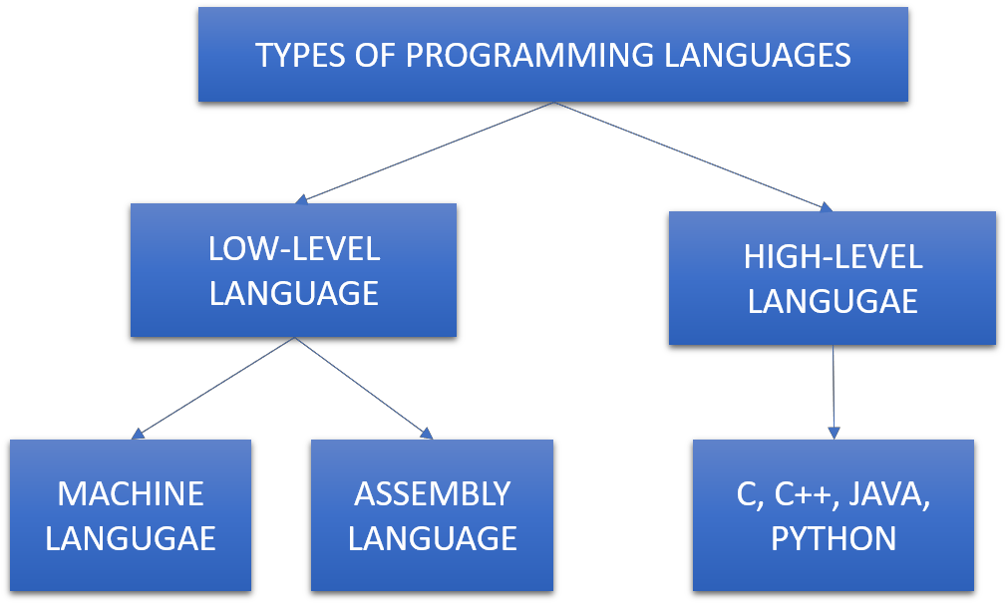

The different types of programming languages are classified and described as follows:

1. Low-level programming language
   * A programming language is known as low-level language because they are very close to hardware elements of a computer.
   * They are machine oriented and require extensive knowledge of computer hardware and its configuration.
   * The low-level programming language is further divided as:
     + Machine language
     + Assembly language
   * Machine language is the only hardware specific and not portable language that is directly understood by the computer and it does not require any translation. All instructions use binary notations and it is written as a string of 0’s and 1’s, but it is difficult to understand by humans and hence assembly language was introduced.
   * Assembly language is the second-generation language, it is the first step to improve programming structure and make machine language more readable by humans. It consists of set of symbols and letters, it requires a translator to translate assembly language to machine language. This translator is known as assembler.
   * Assembly language is easier than machine language but they are still difficult to understand and hence high-level programming language was introduced.

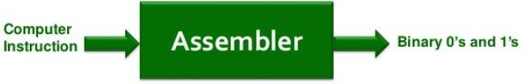

1. High-level programming language
   * High-level programming language uses English and mathematical symbols in its instructions.
   * It is much closer to the human logic but it is not understood by the computer directly hence a translator is required. There are different types of translator: a) compiler and b) interpreter
   * Compiler: the entire code is compiled in one step prior to execution and once compiled no need to compile it again and again.
   * Interpreter: It translates the code one by one during execution and hence this process is to done every time during execution.
   * The different high-level languages are C, C++, JAVA, Python
   * The following table shows the difference between compiler and interpreter

